به نام خدا
تحقیق در عملیات1 – فصل دوم - کوئیز سه‌شنبه 9 آبان 1402
نام و نام‌خانوادگی: شماره دانشجویی:
1- You are managing the distribution of a product from 3 supply centers to 4 demand centers. The supply centers have different capacities, and each demand center has specific requirements. The transportation costs per unit from each supply center to each demand center are known by table below.

Demand Supply | Demand center 1 | Demand center 2 | Demand center 3 | Demand center 4 | Total supply
Supply center 1 | $5 | $4 | $6 | $8 | 400
Supply center 2 | $7 | $5 | $4 | $9 | 300
Supply center 3 | $3 | $6 | $8 | $7 | 500
Total demand | 200 | 150 | 250 | 400

Formulate the transportation problem to minimize the total transportation cost.

2- A bakery produces four types of bread (A, B, C, and D) using three different types of flour (X, Y, and Z). The cost of each type of flour and the recipe for each bread type are known. Also, this bakery wants to produce at least 300 units of A, 250 units of B, 150 units of C and 400 units of D. Your goal is to formulate a linear programming model to minimize the cost of producing these bread types while meeting the daily production requirements.
- Flour Costs (per unit):
- X: $3
- Y: $4
- Z: $2
- Bread Production Requirements:
- Bread A: Requires 2 units of X, 1 unit of Y, and 3 units of Z.
- Bread B: Requires 3 units of X, 2 units of Y, and 1 unit of Z.
- Bread C: Requires 1 unit of X, 2 units of Y, and 2 units of Z.
- Bread D: Requires 2 units of X, 1 unit of Y, and 2 units of Z.

1- Transportation Problem:
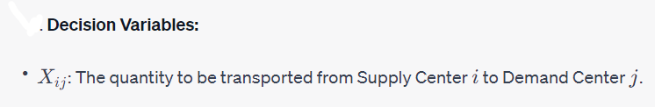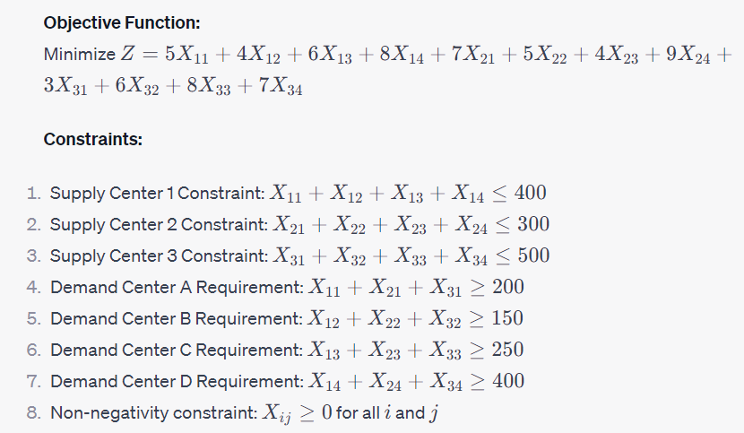
2- Intermixture problem:
Decision Variables:
- X: The quantity of flour X to use.
- Y: The quantity of flour Y to use.
- Z: The quantity of flour Z to use.
Objective Function:
Minimize Z = 3X + 4Y + 2Z
Constraints:
1. Bread A Requirement: 2X + Y + 3Z ≥ 300
2. Bread B Requirement: 3X + 2Y + Z ≥ 250
3. Bread C Requirement: X + 2Y + 2Z ≥ 150
4. Bread D Requirement: 2X + Y + 2Z ≥ 400
5. Non-negativity constraint: X ≥ 0, Y ≥ 0, Z ≥ 0

